Lecture 6
CO1: Apply the knowledge about the concepts of probability and statistics for the computer applications.
CO3: Apply the knowledge about basic ideas of statistics including measures of central tendency, correlation and regression.
Measures of Dispersion
Mean Deviation
Mean Deviation of a set of observations is the arithmetic mean of absolute deviations from mean or any other specified value.
Given the observations $x_{1}, x_{2}, x_{3}, …,x_{n},$ in order to find ‘Mean Deviation about A’, we first obtain the deviations $\left(x_{1}-A\right), \left(x_{2}-A\right), \left(x_{3}-A\right), …, \left(x_{n}-A\right).$ Some of these deviations may be positive and some negative.
If we write $|x_{i}-A|$ to denote the positive value of $\left(x_{i}-A\right)$, whatever be the actual sign, the sum of these ‘absolute deviations’ is
$$\left|x_{1}-A\right|+\left|x_{2}-A\right|+\left|x_{3}-A\right|+ …+\left|x_{n}-A\right|=∑|x_{i}-A|$$
And A.M. of the absolute deviations is
Mean Deviation about A = $\frac{1}{n}=∑|x_{i}-A|$
Mean Deviation is usually calculated arithmetic mean $(\overline{x})$ and hence ‘Mean Deviation’ only refers to M. D. about mean.
For simple series, $M.D. =\frac{1}{n}∑|x_{i}-\overline{x}|$
For frequency distribution, $M.D. =\frac{1}{n}∑f_{i}|x_{i}-\overline{x}|$
Solved Examples
Example 1
- Calculate the mean deviation of the following values about the median: 8, 15, 53, 49, 19, 62, 7, 15, 95, 77.
Solution: Since there are an even number of observations, i.e. 10, the median is the average of the two middlemost observations, when arranged in order of magnitude: 7, 8, 15, 15, (19, 49), 53, 62, 77, 95.
Median = (19+49)/2 = 34
x | $$|x-median|$$
8 | 26
15 | 19
53 | 19
49 | 15
19 | 15
62 | 28
7 | 27
15 | 19
95 | 61
77 | 43
Total | 272

Mean Deviation about mean $=\frac{1}{n}∑\left|x_{i}-median\right|=\frac{1}{10}*272=27.2$
Example 2
- Find the mean deviation of the following series:
X | 10 | 11 | 12 | 13 | 14 | Total
frequency | 3 | 12 | 18 | 12 | 3 | 48
Solution:
$$x$$ | $$f$$ | $$fx$$ | $$|x-\overline{x}|$$ | $$f|x-\overline{x}|$$
10 | 3 | 30 | 2 | 6
11 | 12 | 132 | 1 | 12
12 | 18 | 216 | 0 | 0
13 | 12 | 156 | 1 | 12
14 | 3 | 42 | 2 | 6
Total | 48 | 576 | -- | 36

$$\overline{x}=\frac{∑fx}{N}=\frac{576}{48}=12$$
Mean Deviation = 36/48 = 0.75

Standard Deviation
It is defined as the positive square-root of the arithmetic mean of the Square of the deviations of the given observation from their arithmetic mean.
The standard deviation is denoted by s in case of sample and Greek letter σ (sigma) in case of population.
The formula for calculating standard deviation is as follows
$s=\sqrt{\frac{1}{n}∑{\left(x_{i}-\overline{x}\right)}^{2}}$ for raw data
And for grouped data the formulas are
$s=\sqrt{\frac{1}{n}∑{f_{i}\left(x_{i}-\overline{x}\right)}^{2}}$ for frequency distribution
Example 3
- The standard deviation calculated from a set of 32 observations is 5. If the sum of the observations is 80, what is the sum of the squares of these observations?
Solution: We are given n = 32, $σ=5, ∑x=80.$It is required to find the value of $∑x^{2}$.
Now $σ^{2}=\frac{∑x^{2}}{n}-{\left(\frac{∑x}{n}\right)}^{2}$
$$25=\frac{∑x^{2}}{32}-{\left(\frac{80}{32}\right)}^{2}$$
$$∑x^{2}=1000.$$
Example 4
- The frequency distributions of seed yield of 50 seasamum plants are given below. Find the standard deviation.
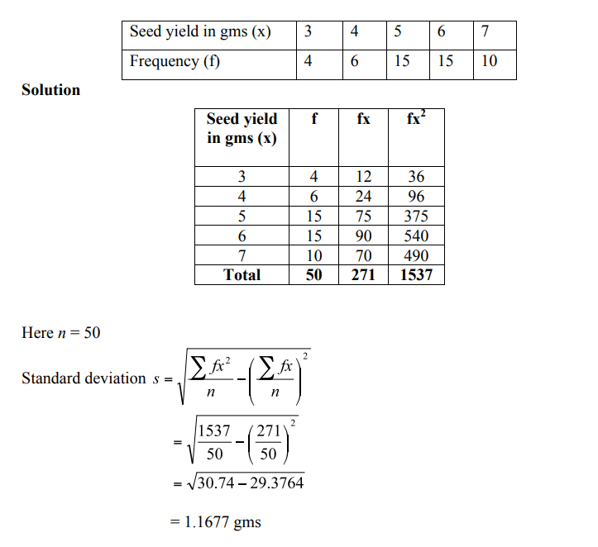
Example 5
- The Frequency distributions of seed yield of 50 seasamum plants are given below. Find the standard deviation.
Seed yield in gms (x) | 2.5-35 | 3.5-4.5 | 4.5-5.5 | 5.5-6.5 | 6.5-7.5
No. of plants (f) | 4 | 6 | 5 | 15 | 10

Seed yield in gms (x) | No. of plants (f) | Mid x | $$d=\frac{x-A}{C}$$ | df | d²f
2.5-3.5 | 4 | 3 | -2 | -8 | 16
3.5-4.5 | 6 | 4 | -1 | -6 | 6
4.5-5.5 | 15 | 5 | 0 | 0 | 0
5.5-6.5 | 15 | 6 | 1 | 15 | 15
6.5-7.5 | 10 | 7 | 2 | 20 | 40
Total | 50 | 25 | 0 | 21 | 77

A=assumed mean=5
N=50, C=1
$$s=C×\sqrt{\frac{∑{fd}^{2}}{N}-{\left(\frac{∑fd}{N}\right)}^{2}}$$
$$s=1×\sqrt{\frac{77}{50}-{\left(\frac{21}{50}\right)}^{2}}$$
$$s=\sqrt{1.54-0.1764}$$
$$s=\sqrt{1.3636}=1.1677$$
Merits and Demerits of Standard Deviation
Merits
- It is rigidly defined and its value is always definite and based on all the observations and the actual signs of deviations are used.
- As it is based on arithmetic mean, it has all the merits of arithmetic mean.
- It is the most important and widely used measure of dispersion.
- It is possible for further algebraic treatment.
- It is less affected by the fluctuations of sampling and hence stable.
- It is the basis for measuring the coefficient of correlation and sampling.
Demerits
  - It is not easy to understand and it is difficult to calculate.
  - It gives more weight to extreme values because the values are squared up.
  - As it is an absolute measure of variability, it cannot be used for the purpose of comparison.

Variance
The square of the standard deviation is called variance
(i.e.) variance = (SD)².
Coefficient of Variation
The Standard deviation is an absolute measure of dispersion. It is expressed in terms of units in which the original figures are collected and stated. The standard deviation of heights of plants cannot be compared with the standard deviation of weights of the grains, as both are expressed in different units, i.e heights in centimetre and weights in kilograms. Therefore the standard deviation must be converted into a relative measure of dispersion for the purpose of comparison. The relative measure is known as the coefficient of variation.
The coefficient of variation is obtained by dividing the standard deviation by the mean and expressed in percentage. Symbolically,
Coefficient of variation (C.V) = $\frac{S.D.}{mean}×100$
If we want to compare the variability of two or more series, we can use C.V. The series or groups of data for which the C.V. is greater indicate that the group is more variable, less stable, less uniform, less consistent or less homogeneous. If the C.V. is less, it indicates that the group is less variable or more stable or more uniform or more consistent or more homogeneous.
Example 6
- Consider the measurement on yield and plant height of a paddy variety. The mean and standard deviation for yield are 50 kg and 10 kg respectively. The mean and standard deviation for plant height are 55 am and 5 cm respectively.
Here the measurements for yield and plant height are in different units. Hence the variabilities can be compared only by using coefficient of variation.
For yield, CV=$\frac{10}{50}×100$= 20%
For plant height, CV= $\frac{5}{55}×100$== 9.1%
The yield is subject to more variation than the plant height.

TEXT BOOKS
- T1 = H. K Dass, Higher Engineering Mathematics, S. Chand Publishers,3rd revised edition.2014.
- T2 = B.S. Grewal, Higher Engineering Mathematics, Khanna Publishers,42th ed.2013, New Delhi.
- T3= N. P. Bali and Manish Goyal, A textbook of engineering Mathematics, Laxmi Publications, Reprint 2008.

REFERENCE BOOKS
- R1=R. K. Jain and S. R. K. Lyenger, Advanced Engineering Mathematics ,3rd Edition Narosa Publishing House ,2004,New Delhi.
- R2 =B. V. Ramana Advanced Engineering Mathematics, McGrawHill, July2006, New Delhi.
- S.P.Gupta,StatisticalMethods,S.Chand&Sons,2017,NewDelhi,ISBN9789351610281Insiders’Guide

Video Lecture :
https://www.youtube.com/watch?v=wuQSeGYQ0ms&list=PL86hgHi3F9FoYVwLPFjVd0fvhPMLIcp0m

